SQL ASSIGNMENT -8

ROLL NO-84016

Q1Assume each salesperson has a 12% commission.Write a query on the orders table that will producethe order number, the salesperson number, and the amount of the salesperson’s commission for that
order.
Ans.
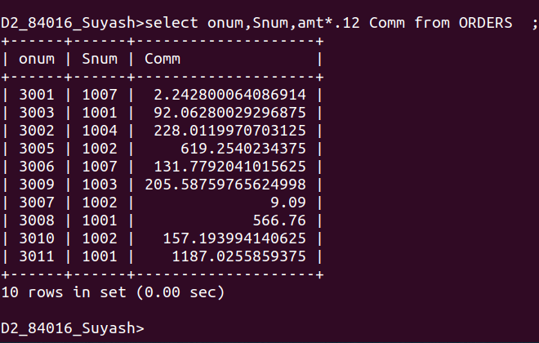

Q2.Write a query on the Customers table that will
find the highest rating in each city. Put the output in this form: For the city (city), the highest rating is : (rating).
Ans.

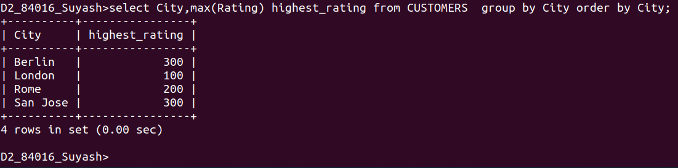

Q3.Write a query that lists customers in descending order of rating. Output the rating field first, followed by the customer’s name and
number.
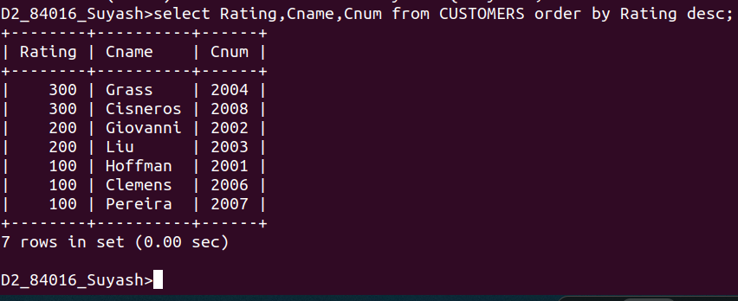
Ans.

Q4.Write a query that totals the orders for each day and places the results in descending order.
Ans.
